**EXPERIMENT 10**

**TRIGGERS**

**Aim:**

* Create a table with attribute sname, and another table with newname.
* Create a trigger to insert into second table before inserting in first table.
* Create a table for account details with attributes account number and an amount.
* Create a trigger to check if amount is negative or greater than zero before inserting to table.
* Create a table with attribute sname, and another table with newname.



* Create a trigger to insert into second table before inserting in first table.

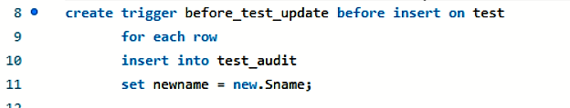

* Create a table for account details with attributes account number and an amount.

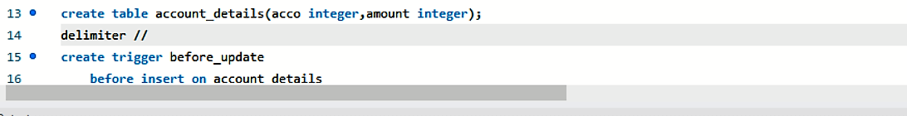

* Create a trigger to check if amount is negative or greater than zero before inserting to table.

